Seestar Notes for Madison Astronomical Society
Prep:
There are Facebook groups for use of the Seestar. You can use the search function and find lots of information there.
https://www.facebook.com/groups/201735739305383 Official group.
https://www.facebook.com/groups/237147005479572 User group.
Download the Seestar app (free) from an app store or from the ZWO support page or Google Play.
https://www.zwoastro.com/software/ or Google Play (android) or Mac app store.
ZWO often updates the app and/or firmware. Firmware will be updated through the updated app automatically, then downloaded from your device to the Seestar if needed.
There are tutorials on the Seestar app home page in the top right corner.

Please READ the PDF User manuals and Safety manuals especially the Tips, for charging and temperature. https://www.zwoastro.com/guides-and-manuals/
Charge the Seestar with a USB-C cable before turning it on. Charge your phone too! Turn on everything ahead of time to make sure there is not a software or firmware update. ZWO does these often. There may be a firmware update and you will “brick” the Seestar if something goes dead while updating (just like any camera).
YouTube videos: YouTube is your friend. Just search Seestar and you will most likely find what you need. A few really good ones are listed here.
*Seestar Astrophotography Made Easy https://www.youtube.com/watch?v=LvJLvvLJGsQ
Seestar and AI: https://www.youtube.com/watch?v=7KmuxZsHCDM&t=5s
Use: https://www.youtube.com/watch?v=mzoweAQ-d2c
Mosaic Mode: https://www.youtube.com/watch?v=ckAAHFnrZkg
Seestar Tutorial For Dummies: https://www.youtube.com/watch?v=x3TXn5GT8SQ&t=1573s
Comets: https://www.youtube.com/shorts/X1JSpD6Smhw

Seestar start up and shut down:
Turn on your phone/tablet’s Bluetooth the first time you connect.
Press SS (Seestar) power button for 2 seconds. Wait for the verbal “Ready to Connect”.
- Connect to Wi-Fi – go to your device’s Settings>Connections>Wi-Fi and connect to Seestar’s Wi-Fi. No internet needed.
- Open the SS app on your device.
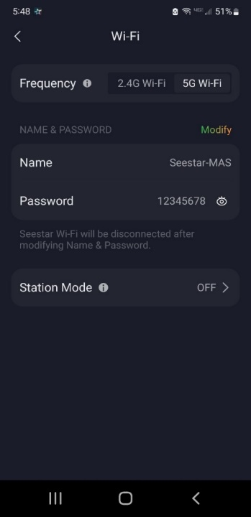
Press Connect. Enter button. Open WLAN settings. Password: 12345678. Stay Connected.
Back out of the phone’s Wi-Fi setup and into the SS app.
If prompted, press the reset button. This is a very small black button on the bottom of the Seestar below the power lights. (Only for the first connection.)
Shut Down: remove any external filters (solar) or dew shield used, cover lens with orange cap, go to the Me (bottom right icon) and use the “Slide To Shut Down”. Always do this before turning off your app.

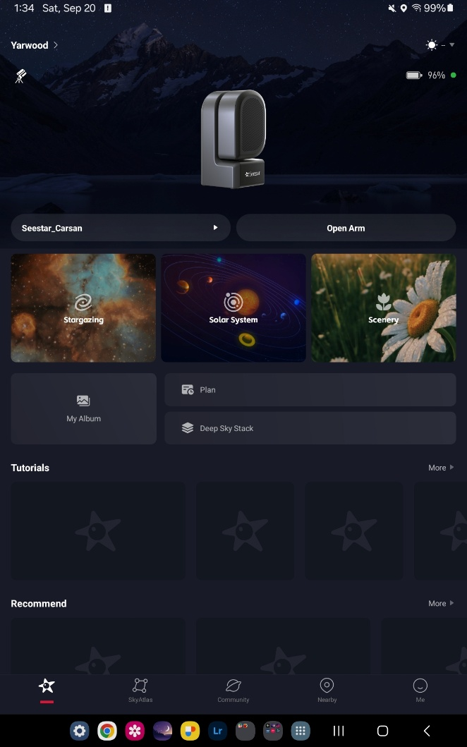
Home Page:
Tutorial (upper right icon)
The different shooting modes: Stargazing, Solar System, Scenery. *TIP: Solar and Lunar are the hardest modes to use since they don’t have a way to identify the sky (platesolve). Don’t start with these. Watch a YouTube to use them.
My Album: The folder on your device containing the saved stacked and processed JPG images (if “save all files” is enabled in the Advanced Settings panel, the FITS files are on the internal hard drive and can be retrieved by a USB-C cable to your computer while the SS is turned on or manually stacked on the SS using Deep Sky Stack.)
Deep Sky Stack: SS can stack your fits files as an optional step if you have set “save all files” on the Advanced Settings panel.
Star icon (on bottom left) is for the Home page.
SkyAtlas: Icon on the bottom bar, or through Stargazing to select an object. Use the magnifying glass to Search or the SkyAtlas to look around the sky for an object.
Me: This is the Settings panel.
Battery icon shows power. If it is blue, it is too cold to charge but can still use an external power bank.

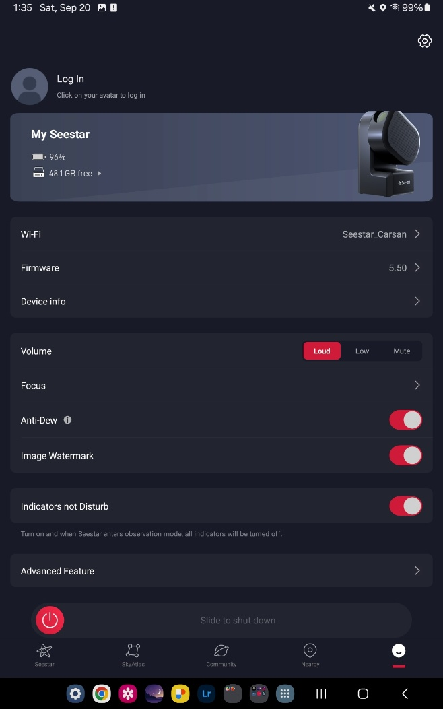
Settings Page:
Tap the Seestar image or the “Me” icon in the bottom right corner to enter the My Seestar settings menu:
Anti-Dew: Turn on the Dew heater if dew is forecasted. This feature will use the battery up faster, but definitely worth not risking having the lens fog up.
Advanced Features Menu > (see next page)

SHUT DOWN PROCEEDURE: Use this slider to shut down the SS. Always do this before turning off your app. Remove solar filter and put on dust cap before turning off.

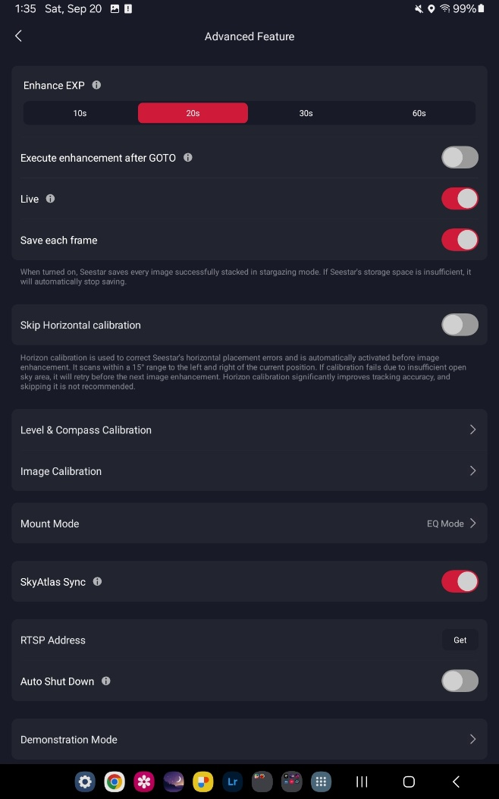
Advanced Features Page
Enhance Exposure > Exposure time in seconds – 10 seconds is best to use for Alt/Az mode (no EQ wedge used). Fewer “Stacking Failed”. You can try 20s.
Live: shows live stacking on the screen.
Save each frame: turn on ONLY if you are going to re-stack yourself using Deep Sky Stack or download every frame to stack in an external software. If not, leave this off as it will fill up the hard drive.
Level and Compass Calibration: see below.
Sync is a setting that can help you tell SS if what is in the center of the screen is the correct target. Sync is not normally needed anymore.

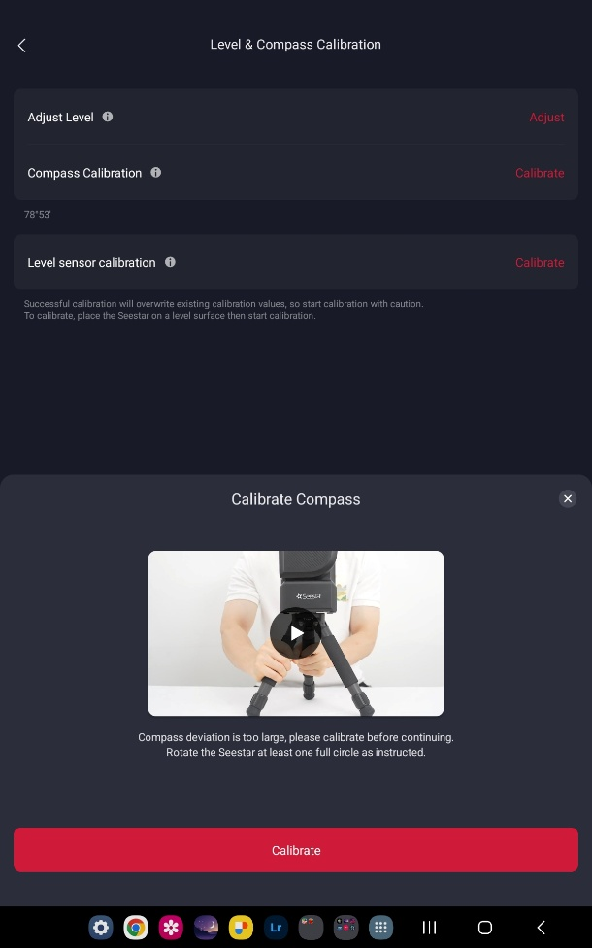
Level and Compass Calibration > *Do the Compass Calibration before you do Adjust Level or you will probably have to do the leveling a second time.
Compass Calibration > follow instructions, turn slowly. It is needed for solar and lunar modes. Otherwise this does not need to be done every time. Just periodically, when changing locations, or after firmware updates.

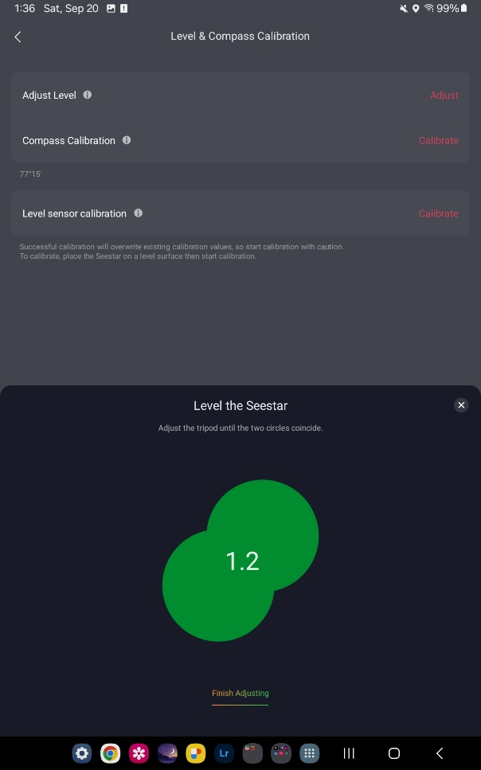

Adjust Level > Follow instructions. Level icon needs to be green. Best to go < 0.3.
Don’t use Level Sensor Calibration as this is only for calibrating the sensor level and is not for field work. Only to be used when there are issues.
Back out of the menu by using the < (back arrow) on top left.
If you are using the original Seestar equipment of just the Seestar and tripod, you will be using Alt/Az mode (Altitude/Azimuth). In this mode, the sensor can only be moved by the motor vertically and horizontally (alt/az).
After making your settings, go back to HOME PAGE (star icon on the bottom) to select Stargazing or SkyAtlas to select an object and begin imaging.
See Finding Targets below.

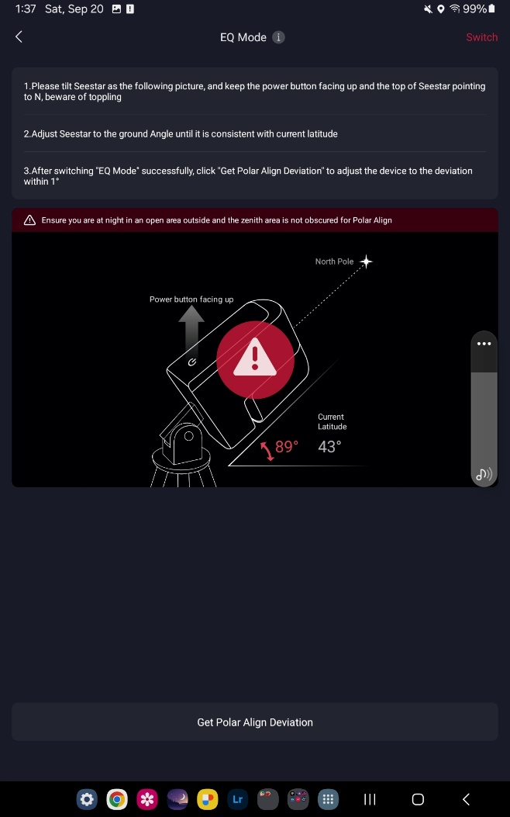
EQ Mode (vs Alt/Az) is optional. You need an additional wedge mount or pan/tilt head to use this feature since it needs a Polar Alignment. There are many advantages to using this advanced feature including being able to use longer exposure times. Find a YouTube video on this new feature.
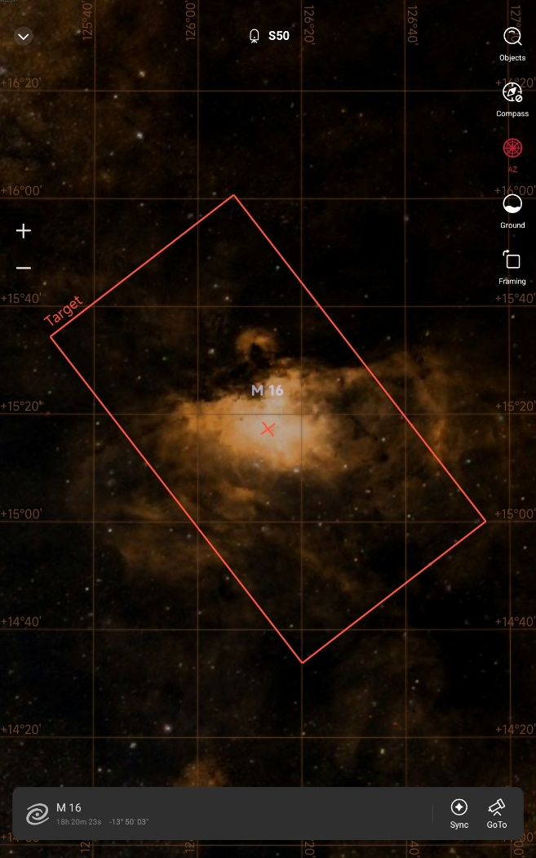
Finding Targets: there are 3 ways to find night sky targets:
Star Gazing; Tonight’s Best; or SkyAtlas button on the bottom panel. Through the SkyAtlas there is a search option on the top right to type in an object name or number or press Compass and hold your phone up see a live sky view. You also can scan around the SkyAtlas and pick a target from there. Select a target. Tap GoTo.
SkyAtlas page icons:
Control icons on the right of the Enhancing screen (hit “i” to see the labels):
Objects: is the search tool
Compass: lets you hold your device up to the sky to locate targets.
AZ: shows the Azimuth or EQ grid.
Framing: will turn on mosaic mode and let you re-frame the target.
Enhancing page icons:
Filter (green circle is On): SS usually turns on the Light Pollution filter for targets with Ha/Oiii. You can also manually turn it on or off. In general, turn it On for emission nebulas and Off for galaxies, star clusters, and reflection nebulas. Do you need it turned on? It usually turns on the Light Pollution filter (which is actually a wide dual band filter: Ha 30nm/Oiii 20mn) for emission nebula. In general, turn it On for emission nebulas and Off for galaxies and reflection nebula. Seestar makes a suggestion for the filter use, but does not always get it right, so check this.
Adjust: only adjust the image on your screen, not the saved file.
Focus: use to turn on Autofocus. This can help SS to find a target. Auto Focus-is used at the beginning before Enhancing/imaging.
Joystick: has a slow and fast speed. This can be used to find the sun or moon if SS is having problems finding them or for re-framing a target (but it is easier to do this by dragging the box in the SkyAtlas).
Mark: will annotate any objects in the SS data base. It does not print on the final jpg.
? : will turn on or off the icon labels.
Start imaging/ Enhancing – tap the red button. SS will go through Horizontal Calibration which is a 3-point calibration and plate solving for the sky. It sometimes fails. Not to worry, just continue. It will try again on the next target. Next, SS takes a set of dark frames which it will apply to all images (light frames), then imaging automatically begins. JPG are saved to your device. (If your images are failing and you are getting star trailing, slew to an open part of the sky not near Zenith (not straight up), and try to image and it will do the Horizontal Calibration. This plate solving will help SS know where it is and then you will get better tracking. Before imaging that plate solving area, stop/cancel and go back to your target. It should not need to do the Horizontal Calibration again that night.
If in Advanced Features you turned on Save All Files, SS saves those to its internal SSD and you must retrieve them later by connecting the SS to a computer via USB-C cable to transfer.

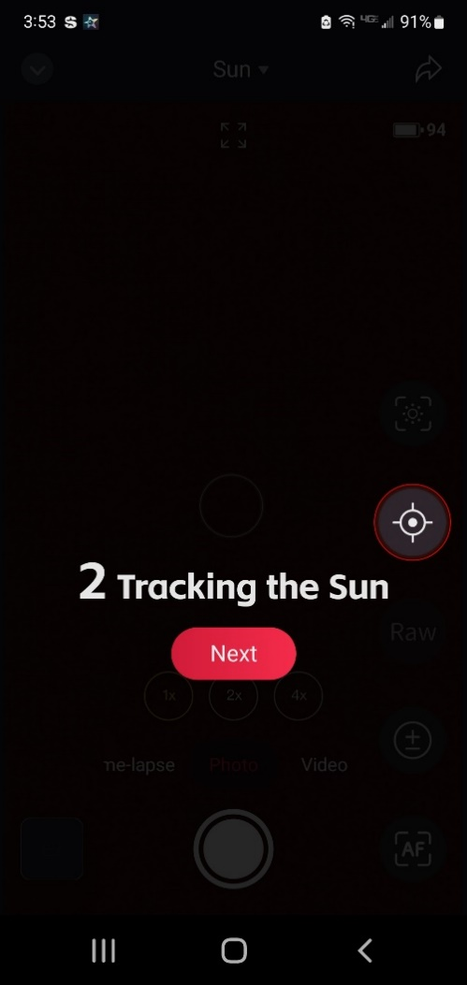
SOLAR
DO NOT TOUCH THE SOLAR FILM! If it gets damaged/punctured, it needs to be replaced!
DO NOT LET SUN GET ON THE SENSOR WITHOUT THE SOLAR FILTER, IT WILL MELT!
SHUTDOWN: LOWER ARM AND REMOVE FILTER BEFORE SHUTTING DOWN.
Solar System > Solar Mode: The Solar instructions will raise the arm just a little and prompt you to install the solar filter before continuing.

In Solar and Lunar Modes the icons on the right are:
Center Target (icon with a planet in center) when you start.
+/- Exposure could be helpful for the moon exposure.
AF autofocus: touch a feature on the sun or moon for it to focus on, then tap AF.
Joystick: use to manually fine sun or moon if SS can’t find it.
RAW (for AVI video) otherwise it will be a MP4 file.
? : turns on and off the icon labels.

