A Hands-On Review: The Orion-Vixen 102mm Refractor OTA for Astrophotography
By Zachary Holcomb, Madison Astronomical Society Member – October 2025
Fellow stargazers of the Madison Astronomical Society,
As our unseasonably warm autumn skies beckon, with the Milky Way still piercing through Madison’s light pollution on lucky nights, I had the opportunity to borrow a club treasure: the Orion-Vixen 102mm refractor optical tube assembly (OTA). This apochromatic scope, essentially a rebranded Vixen FL-102S with a fluorite triplet objective, is a visual observer’s delight (or so I am told) and a compelling option for astrophotography. In early September 2025, I tested it over three nights under Bortle 5.9 skies from my backyard in Waunakee, pairing it with my ZWO ASI 533MC Pro camera. What follows is a detailed review of its performance, complete with duct-tape workarounds, deep-sky results, and suggestions to optimize this club resource.
Setup: Precision Meets Improvisation
The 102mm OTA, with its 940mm tube and featherweight 7.9 pounds, is a joy to handle. Mounted on my ZWO AM5N harmonic drive, it slewed effortlessly—pointing to new targets in seconds without taxing the mount’s 28-pound imaging capacity. After a solid three-point polar alignment, the AM5N delivered a total RMS guiding error of ~0.8 arcseconds, rivaling heavyweights like the Sky-Watcher EQ6-R. Sidereal tracking held steady enough for 30-second exposures, though I guided with a 120mm f/5 guidescope and mini-camera to achieve longer integration times. This worked, but the short focal length of the guide scope stretched its limits; a 200mm+ guide scope would better match the 900mm focal length for pinpoint stars.
Focusing was the trickiest part. The 2-inch Crayford focuser, with 3.125 inches of travel, is optimized for eyepieces but falls ~20mm short for the ASI 533MC Pro. I MacGyvered a solution by duct-taping an extender to the drawtube, which introduced slight tilt and softened corners in unguided test frames. The 533MC’s 1-inch sensor (14.14mm diagonal) couldn’t fully probe field flatness, but central sharpness was crisp with minimal coma. Using the focus feature within ASIAIR, I achieved focus that held steady across 65°F-to-55°F thermal shifts overnight—no autofocus required, though would have been appreciated to achieve smaller stars (which required SIGNIFICANT star reduction in post processing, and in my opinion remain obese in the final processed images).
Sky conditions were cooperative: a half-moon didn’t interfere, and seeing/transparency rated ~4/5. Dew was a challenge; mornings left the tube soaked and me glad for the accompanying dew shield. Cranking a dew strap to max after night one of learning kept the objective clear, though that first night’s flats were useless due to dew-related issues.

Imaging: Galaxies, Clusters, and a Surprise Dwarf
Over three nights, I captured a total of ~8 hours of data on three targets, processed in PixInsight with a simple workflow consisting of WBPP for stacking, GraXpert for gradient removal, Automatic Background Extraction (skipped for M33), Photometric Color Calibration, Screen Transfer Function, Histogram Transformation, Star Reduction, and GraXpert Denoise. Finishing touches were achieved in Photoshop. Calibration was robust, and the scope’s f/8.8 fluorite optics shone. Here’s the rundown:
- M33 (Triangulum Galaxy): A standout with 180 × 60-second subs (3 hours), calibrated with 30 bias, flats, and darks. M33 filled the 533MC’s sensor, highlighting the scope’s 900mm focal length. Dust lanes showed great detail, and the core remained crisp—avoiding the overexposure common in longer shots. The apo’s color fidelity kept hues natural.
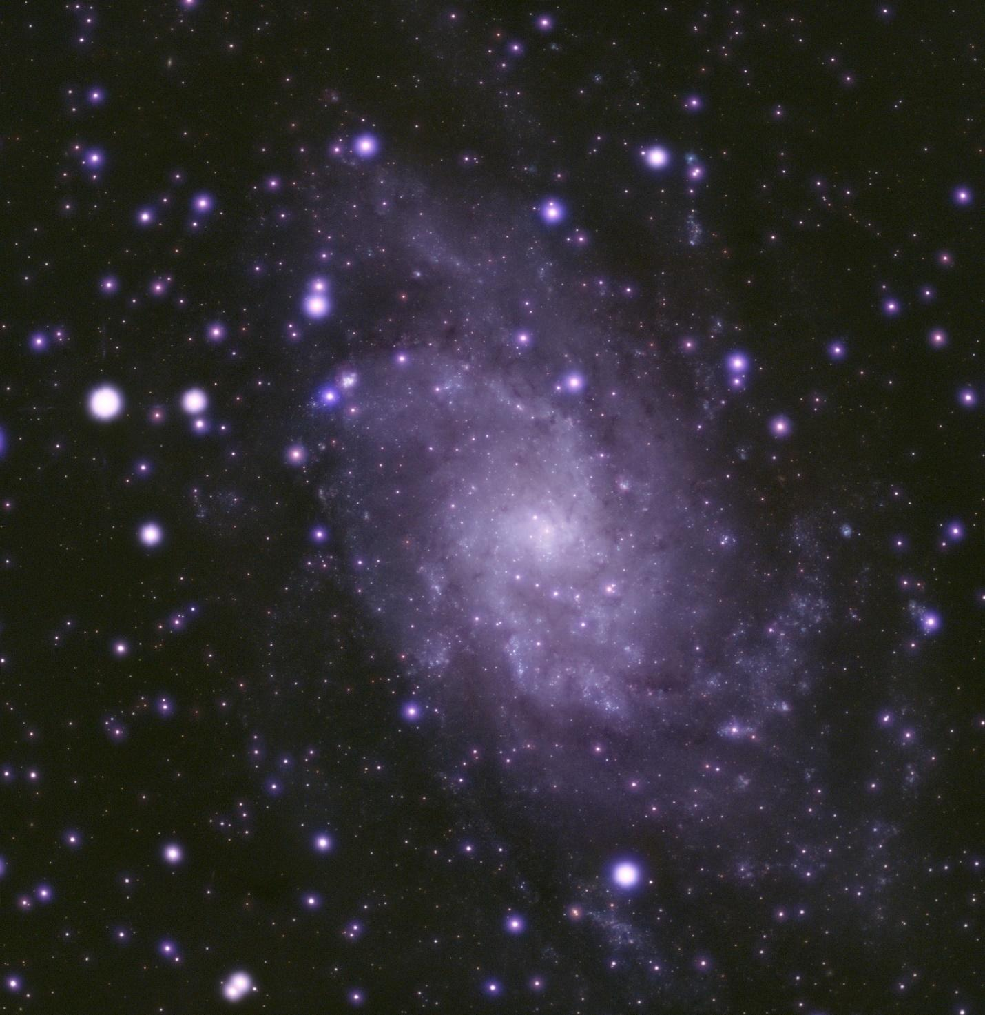
- NGC 7497 (with Interstellar Dust): This edge-on spiral in Aquarius was captured with 26 × 600-second subs (4.3 hours), using 30 bias, darks, and flats. The fluorite triplet’s contrast rendered dust lanes sharply, and a surprise emerged: the faint dwarf galaxy AGC 334638 (only 48.83 arcseconds across) appeared in the stack, a testament to the scope’s light grasp and guiding precision. 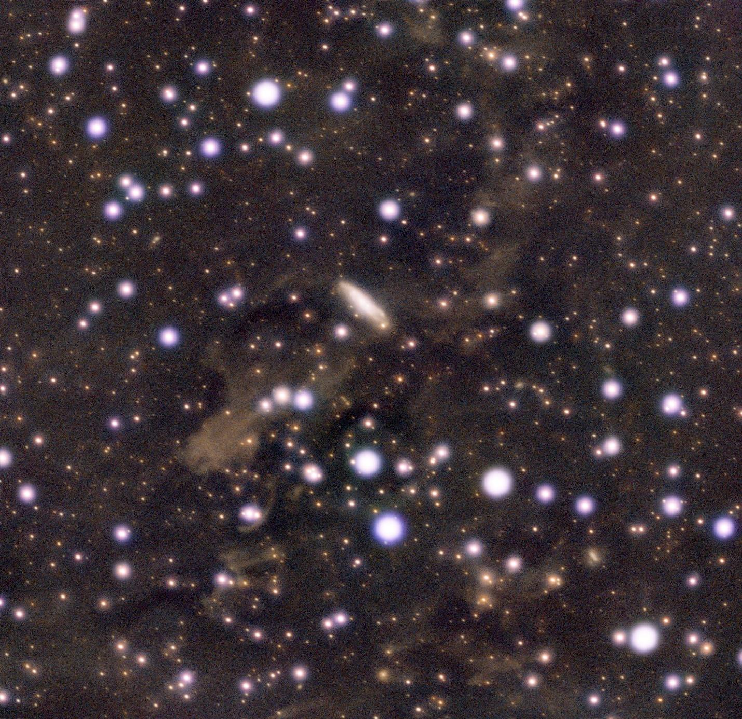

- M13 (Hercules Globular Cluster): A quick 69 × 10-second subs (no darks, 30 bias/flats) resolved M13 into a sparkling jewel box. The scope’s moderate chromatic aberration delivered decent stars with some fringing—good enough for quick cluster shots. NGC 6207 is readily apparent, showing off the reach of the telescope as it is only around 2’ x 1’.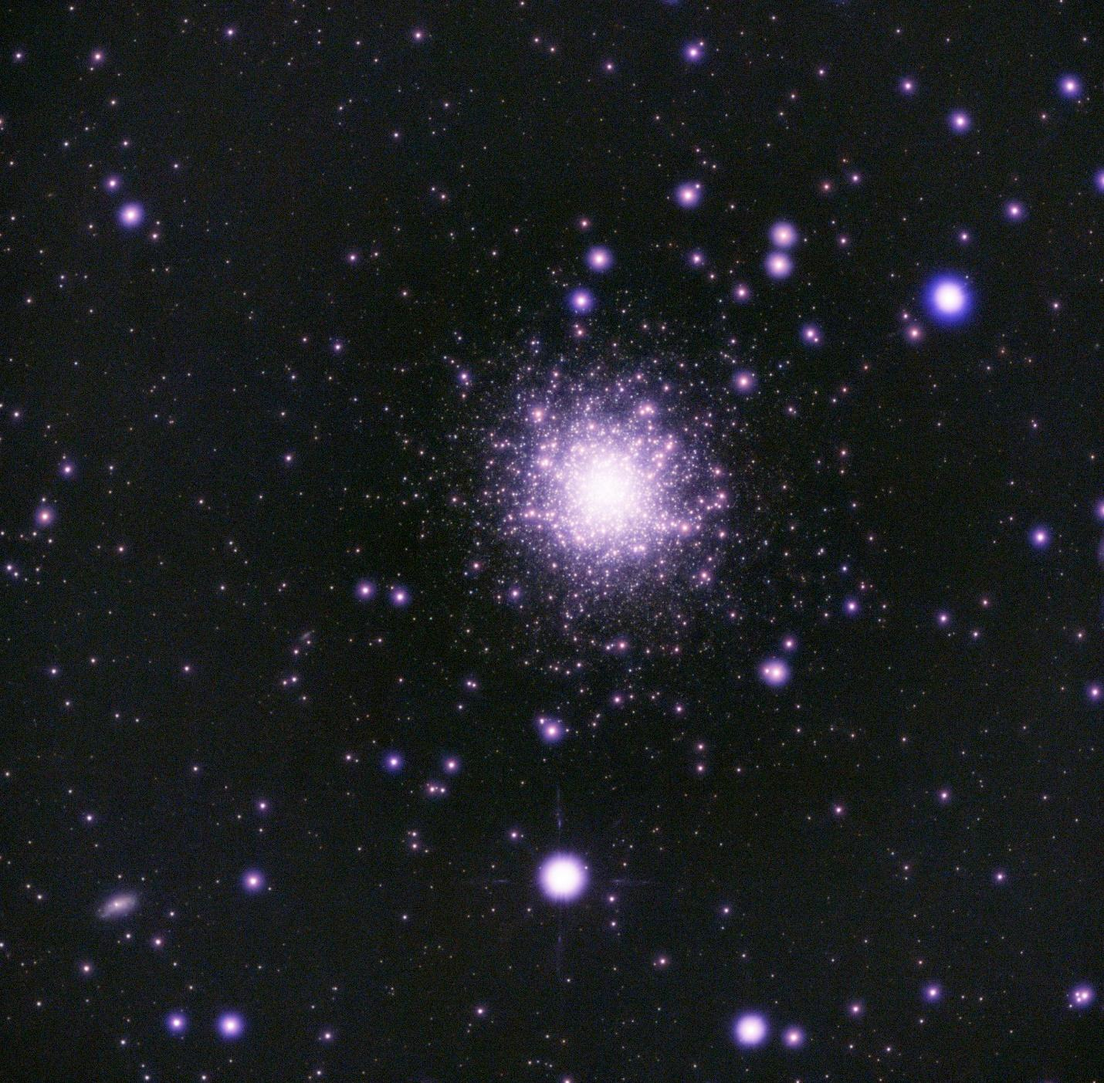

Telescope Specifications
Below are the key specs for the Orion-Vixen 102mm OTA, drawn from Vixen’s documentation and notes from my hands-on use:
Specification | Value | Notes
Aperture | 102mm (4") | Fluorite triplet apochromat
Focal Length | 900mm | Native
Focal Ratio | f/8.8 | Balanced for visual and imaging
Tube Length | 940mm (37") | Without eyepiece holder
Focuser | 2" Crayford | 3.125" travel; rotatable
Weight (OTA only) | 7.9 lbs (3.6 kg) | Lightweight for travel
Backfocus Requirement | 55mm from flange | T-thread compatible

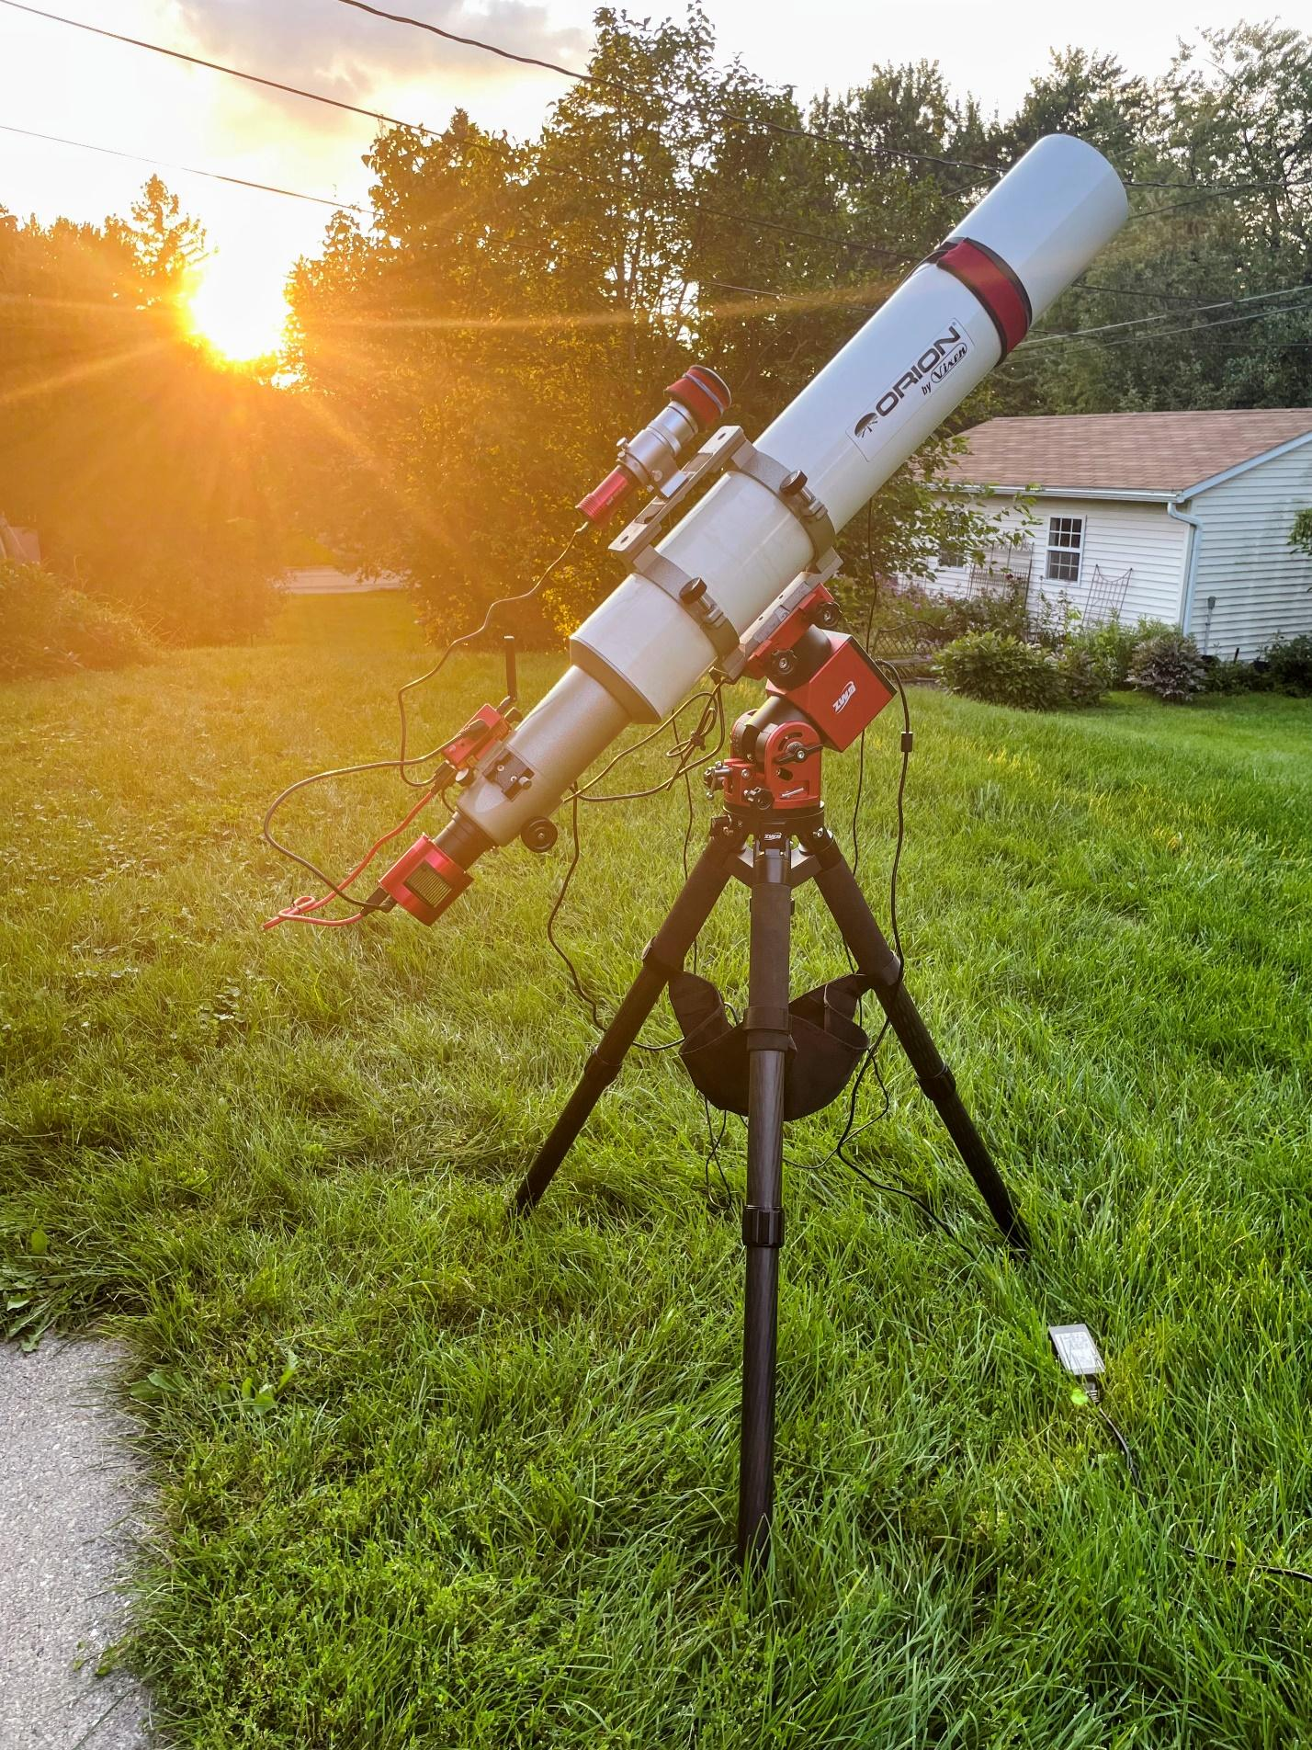
Recommendations for the Club
I rate this scope a 4/5—potentially a 5/5 with minor upgrades. Its portability, sharp optics, and stable focus make it a club standout, but astrophotographers would benefit from:
- Dedicated Adapters: A $20-50 T2 extender or variable spacer would eliminate duct-tape focus hacks. I believe the threading on the optical tube is M54, but should be confirmed before a purchase is made! Better focus would certainly solve a fair amount of star inflation seen in the images above.
- Field Flattener: While my 1” sensor couldn’t test edge performance, a flattener would ensure full-frame sensor compatibility. A focal reducer could also be considered to increase the speed and FOV of the telescope.
- Loaner Kit Guide: Include a list of compatible adapters in the loaner kit for smoother setups.
Final Thoughts
The Orion-Vixen 102mm is a versatile performer, which delivered vibrant images of M33, NGC 7497, and M13 with minimal fuss. Paired with a capable mount like the AM5N or EQ6-R, it’s ideal for portable deep-sky imaging, coaxing out faint details like dwarf galaxies while staying lightweight. Club members borrowing this OTA should plan for focus tweaks but can expect rewarding results. Clear skies, Madison!

